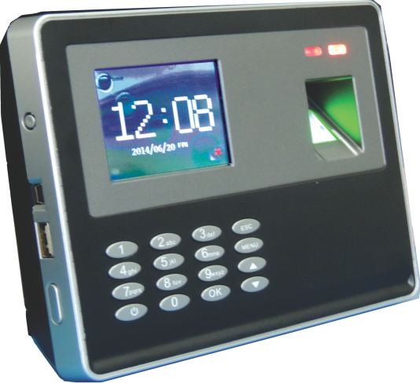

**TIME WATCH BIO-8**

|  |  |
| --- | --- |
| **Finger Capacity** | **3000** |
| **Card Capabilities** | **3000** |
| **Transaction** | **1,00,000** |
| **LCD Display** | **2.8” TFT Colour Screen** |
| **Sensor** | **High-Definition Optical Finger Print Sensor(500PI)** |
| **Hardware Platform** | **LM80B** |
| **FRR** | **<0.1%** |
| **FAR** | **<0.0001%** |
| **Identification Time** | **<1.85** |
| **Identification Mode** | **1:N /1:1** |
| **Identification Mode** | **Fingerprint/Pass ward/ID Card/** **FP+Password/ Card+Password/ FP+Card** |
| **Record Capacity** | **1,00,000psc** |
| **Communication Mode** | **USB, U-disc, TCP/IP** |
| **Language** | **Simple English** |
| **Voice** | **English** |
| **Input Method** | **T9 Input Method** |
| **Ring Inside** | **Multiple sets of custom rings** |
| **Alarm Function** | **Record Full Alarm** |
| **Access Control Interface** | **Simple Open lock Signal/Weigand** |
| **Software Expert Format** | **Office Excel** |
| **Power Supply** | **DC12V/A(100V-240V Available)** |
| **Battery Back up** | **Optional** |
| **Machine Size** | **180*150*50CM (L*W*H)** |